Speaker Biographies & Presentation Information

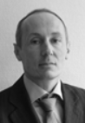 | Mr Eric Fournier  Chairman of the Electronic Communications Committee (ECC), L'Agence Nationale des Fréquences (ANFR), France | Eric Fournier is Director for Spectrum Planning and International Affairs in l’Agence Nationale des Fréquences (ANFR), the public Agency in charge of spectrum management in France.  Mr. Fournier is Chairman of the European Conference of Postal and Telecommunications’ Electronic Communication Committee (CEPT/ECC) and a graduate of l’Ecole Supérieure d’Electricité (SUPELEC).
Welcome & Opening of Workshop
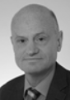 | Mr Thomas Weilacher  Chairman of ECC WG Frequency Management (WG FM), Bundesnetzagentur, Germany | Thomas Weilacher has been working in the field of telecommunications since he finalised the study on electronic engineering. Since 1992 he has been working with the German regulatory authority (now "Federal Network Agency", BNetzA). Until 1995 he had been working in the area of licensing and monitoring in a regional office. From 1996 until now he has been involved in international frequency management issues, by working in the headquarters in Mainz. His tasks include the participation in meetings of ECC groups, Radio Spectrum Committee and ITU-R working parties as a member of the German delegation. Mr Weilacher was also acting as Vice Chairman of ECC Working Group FM from 2008 to the beginning of 2014 and has become chairman of WG FM in March 2014.
Keynote Frequency Management, Session A Chairman, Summary of the Workshop and closing remarks
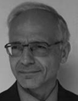 | Mr Antonio Marchetto  RPAS Technologies Expert  European Aviation Safety Agency | Antonio Marchetto, RPAS Technologies Expert for EASA, has been involved in all phases of UAS regulatory developments at the Agency and has been particularly engaged in the process leading to the publication of the Agency’s Opinion on the Open and Specific UAS Categories. He is also involved on U-Space related activities as well as on RPAS certification projects. Before joining the Agency he worked for several years in the military unmanned aircraft domain being deeply involved in the NEURON UCAV program and, previously, in the UAV demonstrator Program Sky-X. He holds a degree in Electronics Engineering from the Turin Polytechnic.
Keynote 2 – New regulatory Framework for UAS/Drones
Panelist
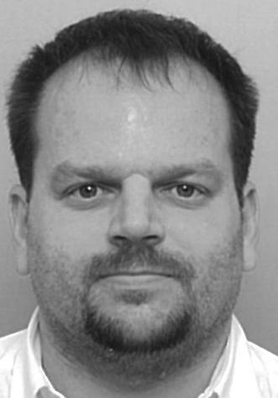 | Mr Florian Cziczatka  FM CG Drones Chairman, Austrian Ministry for Transport, Innovation and Technology, Austria | Florian Cziczatka has been working in the field of national and international frequency management for the Austrian Federal Ministry for Transport, Innovation and Technology since 2005. His tasks besides others in the field of telecommunication include the participation in meetings of CEPT/ECC groups, Radio Spectrum Committee of the EU as well as of World Radiocommunication Conferences and Conference Preparatory Meetings as a member or even acting Head of the Austrian delegation. Mr Cziczatka has been chairman of the WG Frequency Management (WG FM) correspondence group on Drones since February 2015.
An overview of ECC and market surveillance activities (and relation to other regulatory measures) on spectrum use for UAS/Drones

Panelist
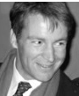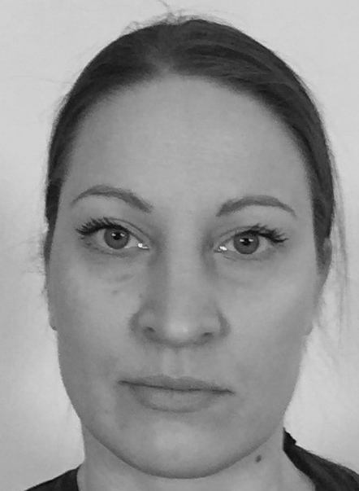 | Dr Michael Sharpe  Director of Spectrum and Equipment Regulation, ETSI  Ms Helka-Liina Määttänen  Ericsson, Rapporteur of LTE  Rel-15 WI on Aerials | Michael Sharpe received his PhD from the University of Essex in the UK. Since then, he has worked at BBC Television, Ford Motor Company and the UK Radiocommunications Agency before joining ETSI in 1995. At ETSI he has occupied several roles, including Vice-President of ETSI Standardisation Projects, Director of Technical Strategy and most recently Director of Spectrum and Equipment Regulation.  In his current role, Michael Sharpe is responsible for ensuring effective co-operation of ETSI’s technical activities with the work of key regulatory bodies and partner standards bodies at the National, European and Global level. His current priorities include working with the European Commission to ensure the smooth introduction of the Radio Equipment Directive, and the continuing close co-operation with CEPT and the Commission Radio Spectrum Unit to ensure that ETSI Harmonized Standards and Regulations on radio frequency use are developed in a co-ordinated and effective manner.  Helka-Liina Määttänen received her M.Sc. and Ph.D. degree in communications engineering from Helsinki University of Technology in 2004 and 2012, respectively. She has been working with 3GPP standards from 2006. She joined Ericsson in 2014 and worked before that at Broadcom and Renesas Mobile/Nokia. Her research interest include downlink MIMO systems, small cells, CoMP, LTE-WLAN interworking, FeMBMS, 5G mobility and Aerials. She has been attending 3GPP WG1 and is currently attending 3GPP WG2 as a standardization delegate. She is rapporteur of LTE Rel-15 WI on Aerials.
Standardisation activities (ETSI and 3GPP) for drones/ UAS; (Dr Sharpe is also panelist)
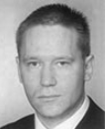 | Mr Christoph Sulzbachner  Senior Research Engineer, AIT, Austria  Mr Hans Peter Stuch, Project Leader, Fraunhofer-Institute FKIE | Christoph Sulzbachner received his MSc degrees in 2006 and 2008. The focus of his university education was on hardware and software development for real-time systems and information management in general. He joined AIT Austrian Institute of Technology in 2008. Since 2012 he is certified as PMP. Since 2013, he is vice-chair R&D in the national UAV working group. He has experience in middle to large-scale projects as he is working and managing national and European-funded projects.  Hans Peter Stuch received his Bachelor degree in 1978 at the University of Applied Science in Cologne with a focus on Communications. He joined what is known since 2009 as Fraunhofer Institute for Communication, Information Processing and Ergonomics FKIE in 1978. After various positions in hardware and software development and liaison engineer, he is group leader of “Jamming” and “Technical Staff” within the Communication System department of FKIE. His tasks include managing of national and EU-funded projects.
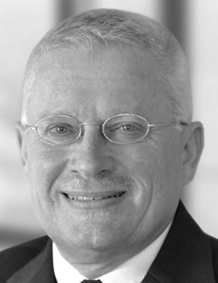

Drone detection & identification
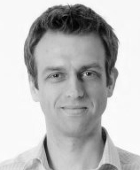 | Dr Michael Judex  Chairman of a Working Group for the use of UAS/Drones, Federal Office of Civil Protection and Disaster Assistance (BBK), Germany | Michael Judex is deputy head of the division “Crisis Management – Principles and IT Processes” in the Federal Office of Civil Protection and Disaster Assistance (BBK), Germany. One of his core areas of work at BBK is remote sensing and geo spatial situational awareness. He is currently leading a multidisciplinary working group to develop a technical regulation for the use of unmanned aerial systems by relief and rescue organizations in Germany. As a Geographer he’s always interested to better understand earth and human activities particularly during crisis situations.
Selected use cases and applicable rules for UAS-Drones used for public protection and disaster relief
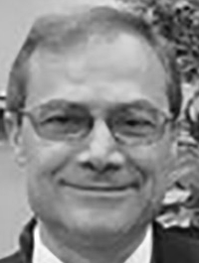 | Mr Raffi Khatcherian  Head of the International Spectrum Management at EUROCONTROL -  The European Organisation for the Safety of Air Navigation | Raffi Khatcherian is a Senior ATM Expert and the Head of EUROCONTROL International Spectrum Management. As the SESAR Spectrum Project Manager, he developed the Aeronautical Spectrum Strategy and Vision. Head of EUROCONTROL delegation at WRC-15. He is the Secretary of Aeronautical Spectrum Frequency Consultation Group (ASFCG); Spectrum Management Group (SMG); ASFCG-IG Interference Group and Aeronautical Radio Interference Analysis group (ARIA).  Before joining the spectrum management; Raffi Khatcherian supported many EUROCONTROL member States in their ATM modernisation programme.
Current EUROCONTROL work programme on drones
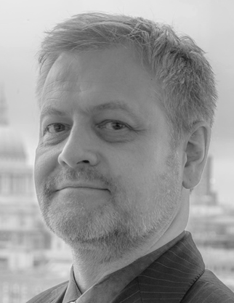 | Mr Stephen Talbot  Vice-chairman of ECC WG FM (Working Group Frequency Management), International Policy Manager, OFCOM, United Kingdom | Stephen Talbot is currently Head of International Spectrum Policy in the Strategy, International, Technology and Economists team of Ofcom (UK) and has been in that position for 2 years. He was the Head of Delegation to CPM15-2 and Deputy Head to WRC-15. During this time he was close the the discussions on Unmanned Aircraft Systems and the issue related to Global Flight Tracking. Stephen holds an HNC in electronic and electrical engineering, and has been with Ofcom since its inception in December 2003. Previous to Ofcom, Stephen worked at the Radiocommunications Agency (the Government predecessor to Ofcom) in a number of posts; Radio Investigation and Monitoring, Satellite and Space Sciences and the International Regulation Team.
Session B Chairman & Views from the British Administration
 | Mr Frank Tofahrn  General Secretary EMFU (European Model Flying Union, Germany | Frank Tofahrn is one of the founders and the General Secretary of the European Modell Flying Union (EMFU) being the largest model flying association in Europe and representing about 130.000 pilots. Within the aeromodelling section of the German Aero Club he is responsible for radio applications and also concerned with regulatory affairs in the national and European air regulation, 3. Chairman of ISAD e.V., Chairman of the EMIG-RC and active in the standardization in ETSI ERM TG11. His profession is the position as head of the ERM-testlab at IMST Gmbh and mainly concerned with the CE-certification of short range devices.
Overview of Spectrum Use of Flying Models
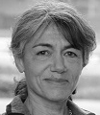 | Mrs Catherine Ronflé-Nadaud  UAS Program Manager, Ministère de la transition écologique et solidaire, France | Catherine Ronflé-Nadaud is Drone Program Manager at the Direction de la Technique et de l’Innovation (DTI) of DSNA (the French Air Navigation Service Provider)  She is ICAO RPAS Panel member for France. From January 2006 to June 2015, she was the head of the UAV Program at ENAC Toulouse (French Civil Aviation Academy). In 1989, she received the ENAC engineer diploma, then a Master of Science in “Fundamental Computer Science and Parallel Computing” from INP Toulouse. She became a DGAC Professional Pilot in 1991 (IFR November 2000, Twin Engine Qualification May 2010).
 | Mr Christian Fleury  French Civil Aviation's Spectrum Manager, Ministère de la transition écologique et solidaire, France | Christian Fleury is Spectrum Manager at DGAC (Direction Générale de l'Aviation Civile). He is ICAO FSMP (Frequency Spectrum Management Panel) Panel member for France. In 1993, he received the ENAC (French Civil Aviation Academy) electronics engineer diploma. From September 2009 to January 2014, he was in charge of the RadioNavigation systems in French Polynesia (SEAC-PF). In 2014, he joined DSNA-DTI-CNS-FRS team as frequency manager; and took the lead of the DGAC's spectrum management in March 2015.
What is mandatory in the different airspace (not only ATC communication) and different requiremenst between VLOS and BVLOS (Beyond Visual Line Of Sight) operation
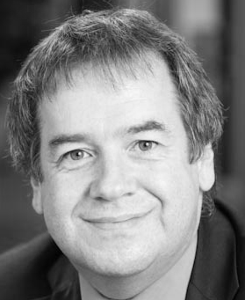 | Mr Lucio Cocciantelli  Head of Section Market Access and Compliance, Federal Office of Communication (Switzerland) ; Chairman of the Group of Administrative Co-operation under the RE Directive | Lucio Cocciantelli, bachelor of science HES-SO in electrical engineering, is active since 1989 in the field of radio communications. He joined the Swiss telecommunications regulator OFCOM in 1997 in the field of the type approval of radio equipment. Since 2012 he is head of the section “Market access and conformity” which is active in the market surveillance in the field of telecommunication equipment. He has been responsible for the implementation of the RED and the EMC directives in the Swiss legislation. He participates to the EU committees of both directives (TCAM and EMC WP). In 2010, he took over the chairmanship of the ADCO R&TTE (group of co-operation between the European market surveillance authorities in the field of R&TTE) which has been renamed ADCO RED because of the entry in force of the Radio Equipment Directive (RED).
Administration View and lessons learned from the ADCO market surveillance campaign on Remotely Piloted Aircraft Systems
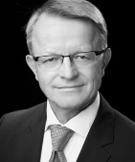 | Mr Christoph Legutko  Government and Policy – CEE Director, Intel Deutschland GmbH, Germany | Christoph Legutko is responsible for the broadband communication policy in the German speaking and Central East European countries for the Government & Policy Group of Intel Corporation. He represents Intel towards European Commission, the European Conference of Postal and Telecommunications Administrations (CEPT), and other regulatory and industrial bodies like Digital Europe or Bitkom. Christoph has joined Intel in 2006. Before he was with Siemens for 22 years.  He was responsible for radio spectrum policy of the Mobile Communications Sector in his last six years there and before, he held multiple leading positions in the sales and R&D departments of the computing and telecommunication sectors of Siemens since 1984.  He began his professional career in a medium-sized electronic company in Germany in 1982 where he developed the distance and movement sensors.  Christoph has studied at the Mining and Metallurgical Academy in Krakow, Poland, and received his master’s degree in Electronics Engineering in 1981.
Types of drones’ operation and generated communication traffic
Panelist
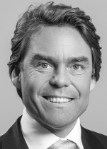 | Mr Jacques Kruse Brandao  Head of Political Affairs & Public Co-Creation, NXP, Netherlands | Jacques Kruse Brandao is Advocacy Partner Secure Digital Identity and Head of Political Affairs & Public Co-creation at NXP Semiconductors. Jacques is in the identification industry for >15y. Today Jacques advocates our partners on Security and Privacy in the hyper-connected world explaining the related needs and the available solutions focusing on ‘Connected Devices’ and ‘Connected Systems’ related to Smart Energy, Smart City, Smart Home and Smart Mobility including UAVs. He also supports discussions around new necessary rules in the U-Space to make the drone business a success.
Secure UAV Operation in the U-Space using IEEE 802.11p - Technologies for Detect-And-Avoid, Drone-to-Drone, Drone-to-infrastructure
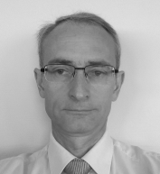 | Mr Christophe Dress  Aero Communications Marketing & Strategy Director,  Thales Group, France | Christophe Dress is strategy and marketing director at THALES group for the Aeronautical Communications since 2013. He is leading the product line policy for all equipment and solutions for Communications, Navigations and Surveillance/Identification. Before, he held various position related to communications equipment at Thales Group. He was in in particular in charge of Radio-Navigation and Communications frequency compatibilities studies, and integrations projects of CNI equipment onboard aircraft.  He is a graduate of Ecole Polytechnique, and received a PhD degree in Physics from the University Paris VI.
Safety, security and ecosystem for professional UAS:
a view on frequency regulation
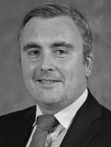 | Mr Kenneth Concannon  Spectrum Management, COMREG, Ireland | For the past 16 years, Kenneth has occupied a number of roles within the Commission for Communications Regulation (ComReg). Prior to the formation of ComReg, he worked for 2 years in the ODTR (ComReg’s predecessor). Currently working within the Spectrum Policy and Development unit, he has represented ComReg at various CEPT/ECC working groups, dealing with diverse spectrum management topics ranging from short range devices (SRD) to mobile/fixed communications networks (MFCN). He currently participates at WGFM meetings, working to develop strategies, plans and implementation advice to effectively manage the radio spectrum. At the World Radiocommunications Conference in 2015, Kenneth also held responsibility for presenting Irish views on spectrum matters related to the mobile service. In addition to international work, he is also presently engaged in managing the development of a study regarding Future Mobile Connectivity within Ireland. Kenneth holds a BSc in Applied Physics and an MSc in Work and Organisational Behaviour, both from Dublin City University.
Session C Chairman
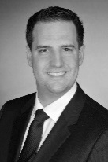 | Mr Jan-Hendrik Jochum  Spectrum Policy & Projects, Deutsche Telekom, shared with Deutsche Flugsicherung, Germany | Jan-Hendrik Jochum is an expert in Spectrum Policy at Deutsche Telekom AG (DT), where he is responsible for spectrum management and projects. He is leading all kinds of projects for airspace connectivity from a regulatory perspective within DT. Jan joined DT in 2009 and works in the regulatory sector since 2014. Prior to joining DT he was working in different projects in Europe for a consultancy. Jan holds a Master of Arts in Political Sciences from the University of Bonn, Germany.
Drones/ UAS used in existing MFCN networks
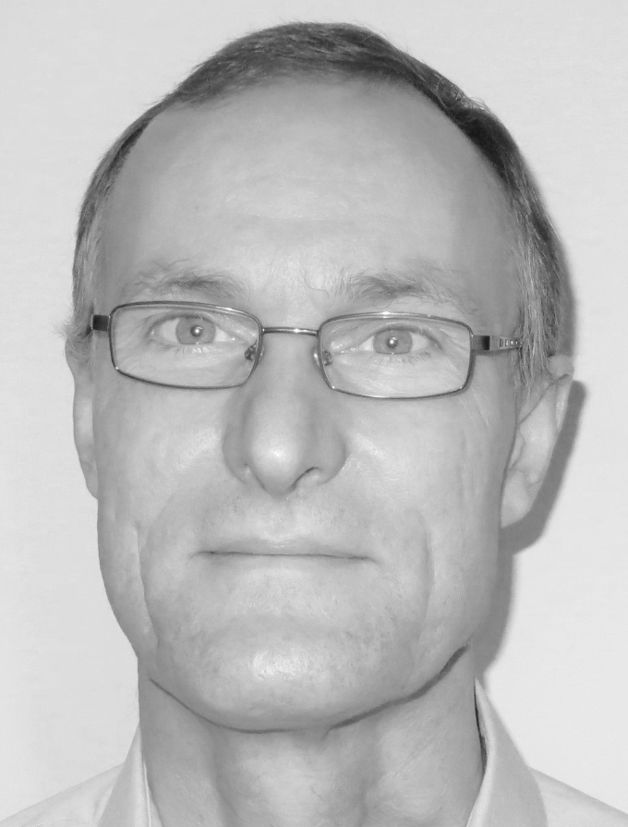 | Dr Eric Murray  Principal Engineer, Vodafone New Technologies and Innovation, United Kingdom | Dr Murray is Principal Engineer within the Vodafone Group Technology Networks Centre of Excellence, where he has worked since 2014. He is responsible for identifying and developing new technologies and innovations of interest to the Vodafone Group of companies, and evaluating them in proof of concept trials. As part of a small team, Dr Murray was responsible for developing the original “Flying CrowdCell” demonstrated at MWC’17, and later for trials demonstrating the benefits of cellular connectivity for drones, both for customers and regulators. This lead to a successful trial of a network-based drone tracking technology that was demonstrated in Spain in late 2017. He is also working with Vodafone’s radio equipment suppliers on trials of network optimisations that improve cellular network performance when serving drones.
Trials of Mobile-Connected Drones and the Benefits of Operator-Managed Licensed Spectrum
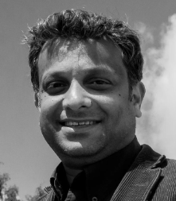 | Mr Ayan Ghosh  Everything Everywhere (EE)/BT Group, United Kingdom | Ayan has worked in the telecoms industry since 2001 for companies like Motorola, Nokia, EE and BT. After completing his BEng degree in IT and Masters in Computer Science from UMIST, Ayan rolled out the first WiMax network in the country. Working under Prof Dr Simon Saunders, Ayan was involved in designing wireless communication systems in some of the most iconic stadiums, shopping centers and public buildings in the country including Wembley, Ascot & Heathrow. Ayan was also involved in leading international cross functional teams within Motorola and Nokia to provide support on 3G and 4G products. Thereafter Ayan was involved in designing and testing EE’s 4G Multiband LTE and 3G Femtocell roll outs. Recently Ayan designed and developed EE’s patent awaiting Airmast solution using small-cell for which he received the Small Cell World Forum and World MEC Award. Ayan has also developed an A2GC and an in-cabin system for future Airbus planes as part of the ICARO 2017 project. When he is not busy designing networks, Ayan plays cricket for Painswick Cricket Club in the Gloucestershire League and rides his motorbikes in the Cotswold.
Spectrum for drones in emergency situations and LTE rural access
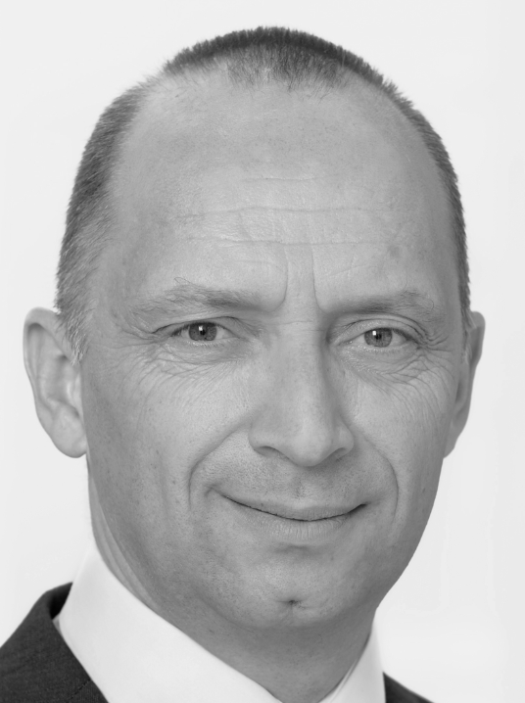 | Mr Luc Haeberlé  Managing Director Colibrex (LS telcom), Germany | Luc Haeberlé has occupied various positions in the telecommunication, test & measurement and safety industry, for example as Director Asia/Pacific Broadcast for Rohde & Schwarz in Munich. In these positions he has often contributed to conferences and workshops for organizations like the Asia-Pacific Broadcasting Union (ABU) or the ITU.  In 2013 he joined the German spectrum management specialist LS telcom being in charge of developing a new subsidiary (Colibrex) involved in drone operation & drone management. As specialized drone operator Colibrex is offering airborne radio frequency measurement services worldwide with applications like frequency monitoring “in the air” or measurement of NavAids installations at the airports. As Managing Director of Colibrex, Mr. Haeberlé is developing these activities in various countries and represents the company in international organizations.  Luc Haeberlé holds a Double French-German degree in business administration for technical goods.
Spectrum as a key issue in both drone operation and drone surveillance
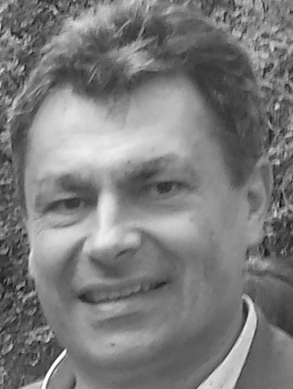 | Mr Johannes Hecht  Chief Engineer and Head of Design, Schiebel, Austria | Mr Johannes Hecht was working since the early 90‘s on the Technical University in Vienna on Remotely Piloted Vehicles and since 1994 with Schiebel on Rotary Wing UAVs. He went through all phases of development and operation of a mid-sized UAV product beginning in 1997 with the first CAMCOPTER® 5.1 until today with the current product CAMCOPTER® S-100. The CAMCOPTER® S-100 is a worldwide operationally proven capability for military and civilian applications and can carry a 34 kg payload for 6 hours up to 200 km over land and sea. Mr. Johannes Hecht is Chief Engineer and Head of Design.
CAMCOPTER-Future UAS Requirements out of Experience
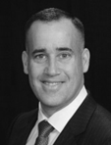 | Mr Brad Beach  Director, UAS Denmark Testcenter | Brad Beach is the Director of UAS Denmark Test center located at Hans Christian Andersen Airport. The Test Center is focused on providing public and private companies and research institutions an opportunity to conduct visual and beyond visual line of sight UAS operations in controlled urban, rural, and maritime environments. He is currently working on the Innovation Fund Denmark project “Free the Drones” to enable commercial BVLOS flights in Denmark. He is also leading a Danish Ministry of Higher Education and Science Infrastructure funded project to provide UAS scientific payload platforms for data collection and provide facilities for UAS platform research, development and test.  Brad is also the Director of the University of Southern Denmark UAS Center under the Faculty of Engineering and the Maersk McKinney Moller Institute. He has over 35+ years of aviation experience as a private, commercial, military, and drone pilot. As the former U.S. Marine Corps UAS program and requirements officer, he has worked on the RQ-11 Raven, RQ-12 WASP, RQ-20 Puma, RQ-7B Shadow, Kaman K-Max, and RQ-21 Integrator programs.
Reliable and Redundant Communications in the Danish Drone Test Environment
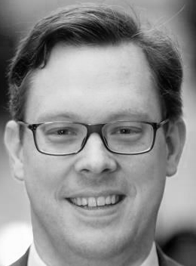 | Mr Robert Heiliger  Member of the Board of Directors, European Utilities Telecoms Council (EUTC) | Energy Networks Business Development  Robert Heiliger is working in business development for energy networks on group level. Furthermore he is representing E.ON in EUTCs Board of Advisors. He has more than 10 years’ experience in the energy industry. Prior he was the Head of Innovation Energy Networks at E.ON SE, coordinating E.ONs R&D activities related to distribution of electricity, gas and heat. As such he, together with his team, introduced drones as a means to support with grid maintenance in E.ON. Before joining the Innovation division he worked as Senior Engineer at E.ON NewBuild & Technology, E.ONs group engineering company, being responsible for a team engaged in telecommunication solutions for renewables and gas infrastructure. For E.ON NewBuild & Technology he furthermore worked as project manager and specialist on numerous projects in a number of countries, amongst others UK, Sweden, Israel and the Central Eastern European states. He holds a diploma from “University of applied science South Westphalia” in electrical engineering, specialised in automation.
Drones in utilities day-to-day operations as well as during emergencies; flight control, backhaul, overcoming limits to line-of-sight operation
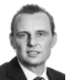 | Mr Thomas Weber  Spectrum Management Expert,  European Communications Office | Thomas Weber joined the European Communications Office of the CEPT in 2010 as expert for spectrum management and is the chairman of the WG FM Maintenance Group on Short Range Devices (SRD/MG – this includes ITS and Urban Rail applications). He is also responsible for the frequency management project teams and forum groups in the WGFM dealing with the ECO Frequency Information System (EFIS), PMR/PAMR, railway applications, the European Common Allocations Table, radio amateur matters, and Drones/UAS.  Before that, he worked for the Federal Network Agency in Germany in 2001-2010 and was the chairman of several ETSI standardization groups dealing with ITS, PMR, DMR, GSM-R and UWB as well as the chairman for the DIN/DKE German National standardization committee on radio devices. He also worked several years for several satellite operators and in the industry in satellite communications. He holds a degree in Communications Engineering acquired at the University of Applied Sciences in Dieburg, Germany.
Session D Chairman
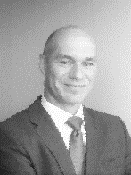 | Mr Andreas Geiss  European Commission  DG Communications Networks, Content & Technology, Head of Unit B4 – Spectrum Policy | Andreas Geiss is Head of Unit for Radio Spectrum Policy in DG CONNECT of the European Commission. He is the Chair of the Radio Spectrum Committee. He has been working for the European Commission since 2002 in various positions. His responsibilities included mobile communications, the Radio Spectrum Policy Programme and negotiations with the Member States in different settings. Before joining the European Commission he worked for the European Radiocommunications Office (ERO), where he was project leader for projects dealing with terrestrial and satellite communications. He has been involved in the European preparations for World Radiocommunications Conferences since 1995. Andreas has a master's degree in electrical engineering and started his professional career in 1991 at the German Regulatory Authority in the area of telecommunications.
View on UAS/Drones Spectrum Use
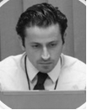 | Mr Miguel Capela  Spectrum Planning and Engineering Expert  Portuguese Regulator ANACOM (Autoridade Nacional de Comunicações), Portugal | Miguel Capela, is working in Spectrum Planning and Engineering since 2000 in the Portuguese Regulator ANACOM (Autoridade Nacional de Comunicações). He has a degree in Electronic and Telecommunications Engineering granted by Universidade de Aveiro in 2000, a post-graduate degree in mobile communications granted by Universidade de Aveiro in 2002 and a post-graduate degree in Telecommunications and Information Technologies granted by Instituto Superior Técnico (Lisboa) in 2010.  In CEPT he was and is participating in several CEPT groups (e.g., SRD/MG, EFIS/MG) including drones activity and was technical secretary of ECC TG6 on Long Term Vision UHF.
Views of the Portuguese Administration
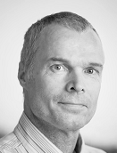 | Mr Petteri Jokela  Senior Specialist, Spectrum Management Regulatory Authority (FICORA), Finland | Petteri Jokela has worked in the Finnish Communications Regulatory Authority since 1992, when he received his post-graduate degree in Space Technology and Radio Communications from Helsinki University of Technology. He has developed spectrum planning tools for interference calculations. He has worked as head of satellite section in 1995-1998, and as head of radio monitoring centre in 1998-2005. Currently he is working on aeronautical, both civil and military, radio matters including drones. He is also team manager for public mobile network coverage issues. Since February 2005, he has chaired WG SE Project Team 7 on compatibility and sharing studies for mobile services.
Views of the Finnish Administration
 | Mr Vincent Durepaire  Senior spectrum management expert  L'Agence Nationale des Fréquences (ANFR), France  Mr Antone Borissov  Spectrum management expert,  L'Agence Nationale des Fréquences (ANFR), France | Vincent Durepaire is senior spectrum management expert at the ANFR, Vice-chairman of the WG FM and chairman of WG FM project team FM56 (Radio Spectrum for Railway Applications). Before that, he worked for Ericsson, Bouygues and Kapsch CarrierCom.  Antone Borissov has been working for Agence Nationale des Fréquences since 2014 on various spectrum management issues including PPDR and GSM-R, and represents the French administration in the ongoing discussions on drones within CEPT. He holds a Master of Science in Electronic Engineering from ENSIETA/ENSTA Bretagne. From 2007 to 2014, he worked for the French MoD on the specification and qualification of drone systems, in particular with respect to their navigational and intelligence gathering capabilities.
Views of the French Administration
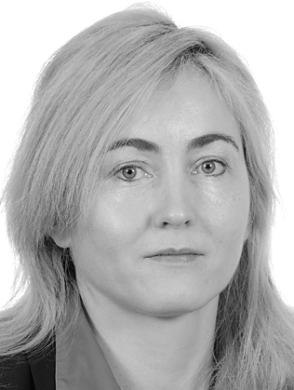 | Ms Aire Siinvert  Technical Regulatory Authority, Estonia | Aire Siinvert is responsible for strategical planning of radio spectrum for a year, also as certified auditor for ISO Quality Management System for 3 years at Technical Regulatory Authority. Previously Aire worked as Head of Aeronautical and Maritime search and rescue coordination centre (JRCC); before as Team Leader to establish TETRA operational radio communication network monitoring and surveillance center.  Aire holds degrees from Estonian Maritime Academy (Radio Engineer), Estonian Aviation Academy (Aviation Management), Tallinn University of Technology (bachelor in Public Management and master in Crisis Management). In addition, Aire has been working as chief radio station onboard ships; Reval Marine and Offshore Training Academy as lecturer-instructor; Highschool (guest-teacher).
Views of the Estonian Administration

